NJCU Institutional Review Board Email: [kresch@njcu.edu](mailto:kresch@njcu.edu)

##### Investigator’s Checklist for IRB Submission

Please make sure that your application is complete prior to submitting it to the NJCU IRB. Please save the entire application and all supporting documents as one word document. Please make sure that your file name includes your full name and please do not use “final” in the file name, as there may be revisions of the original application. Please be certain that your consent form, if applicable, includes all of the information provided below.

All applications must be submitted by the NJCU faculty or staff member listed as the Principal Investigator (PI). Neither students nor external researchers may submit an application. (For all students, a faculty/staff member must serve as the PI. All external researchers must have an NJCU faculty/staff member as a sponsor.)

Submit the completed application and accompanying documents as one word document to [kresch@njcu.edu](mailto:kelly@njcu.edu).

##### Application

* Completed and signed Proposal Submission Form
* Protocol Summary (5-page limit) that identifies the research question and describes methods
* Copies of data collection instruments that coincide with the study described in the Protocol Summary
* Recruitment materials (as applicable)
* Consent document(s) or the rationale for deviation from written consent
* Certificate of training in protection of human subjects from the Collaborative Institutional Training Initiative (CITI Program) (<https://about.citiprogram.org/>) for **all** researchers involved in the project. A separate

guidance is available on CITI certification programs.

Please ensure that **all consent forms** are written for a general audience; are specific to subjects (and/or their

parents/guardians); identify the researcher, the researcher’s position, and his/her institution; and:

* Describe the study and the procedures (activities, duration, and/or audio, photographic, or videotaping*) in lay terms
* Clearly state that there are no benefits or known risks or clearly explain the precautions that will be taken if there are risks (Monetary payment does not constitute a benefit.)
* Include a statement that participation is voluntary and that all subjects have the right to skip any questions or activities and to opt out at any time without penalty
* Provide the names of all contact persons for the study, including the Principal Investigator and, for external researchers, the NJCU sponsor
* Include this statement: “If you have questions about your rights as a participant in this study, please contact

Dr. Meriem Bendaoud, chair of the NJCU IRB, at (201) 200-3310 or [mbendaoud@njcu.edu](mailto:mbendaoud@njcu.edu).

* Include a statement of confidentiality**
* Have places for signatures and the date.
* Furthermore, for any study using audio, photographic, or video recordings, the researcher must also completely explain the use of these recordings, the plan for their storage, and also, if and how this information will be protected and disseminated.

** If the research project is planned to deviate from complete anonymity, the researcher may include a waiver to use the names of respondents, but the researcher must specify how all data will be used and disseminated.

Please expect acknowledgement of your submission within 5 working days. If there is no acknowledgement, please email [kresch@njcu.edu](mailto:kresch@njcu.edu).

## NJCU Institutional Review Board Application for Review of Research Project

Email all materials in one word document to: [kresch@njcu.edu.](mailto:kresch@njcu.edu)

**Date of Submission**: Click or tap to enter a date.

##### Name (PI)/Sponsor Submitting Application:

**Application Type**: ☐Original ☐ Previously Approved

|  |  |
| --- | --- |
| Proposal Title | Podcast Listeners and Informal Learning |
| Proposed Start Date | 1/1/2022 |
| Anticipated Duration of Research | 4 months |
| CITI Certification by all researchers (Certificates must be  attached.) | See attached |

##### Type of Research

☒Student/Classroom project

☒ Faculty research project

`Staff research project

* + External researcher project (All external researchers must have an NJCU faculty/staff sponsor.)

##### NJCU Investigators (Please list additional investigators as necessary)

Name: Juan Rodriguez Department: Educational Technology Telephone number: 201-200-3078

Email address: [jrodriguez55@njcu.edu](mailto:jrodriguez55@njcu.edu)

*\**Any NJCU investigator who plans to work on this project either with or for a Principal Investigator or a Co - Investigator at another institution must identify those investigators and their institutions below.

**External Investigators**

Name: Click here to enter Name. Department: Click here to enter Department. Telephone number: Click here to enter Telephone number. Email address: Click here to enter Email address.

Name: Click here to enter Name. Department: Click here to enter Department. Telephone number: Click here to enter Telephone number. Email address: Click here to enter Email address.

Name: Click here to enter Name. Department: Click here to enter Department. Telephone number: Click here to enter Telephone number. Email address: Click here to enter Email address.

Name: Click here to enter Name. Department: Click here to enter Department. Telephone number: Click here to enter Telephone number. Email address: Click here to enter Email address.

**Data Sources**

X

NJCU Sponsor

1. Number of participants: 40-50
2. How was this number determined (e.g., power analysis)? Anticipated number for saturation in grounded theory
3. Does this project require the collection of new data? ☒ Yes ☐ No 3A. If yes, how will participants be selected or recruited (<4-5 sentences)?

Participants will be recruited in two ways: through social media, personal and professional network of the researcher..

3B. Will subjects participate on a fully voluntary basis? ☒ Yes ☐ No 3C. Will subjects be compensated for their participation? ☒ Yes ☐ No 3D. If yes, please briefly describe the compensation:

Subjects will receive a $20 Amazon gift card for their participation.

1. Does this project make use of human tissue or cell lines: ☐ Yes ☒ No
2. Briefly describe the research methodology(ies) to be used in this study (e.g., focus group, participant observation, survey, experiment). (<4-5 sentences)

The only method used will be interviews. Each participant will be asked to be interviewed for approximately 60 minutes. These will be live or Zoom. They will be recorded and transcribed. The transcripts will be analyzed using the techniques of grounded theory.

1. Does this project use data that have already been collected for a non-research purpose or by another researcher? ☐ Yes ☒ No

6A. If yes, what is the source of the data? (3-4 sentences)

Click here to enter text.

6B. Are the data accessible in the public domain? ☐ Yes ☒ No

6C. If no, does the data include information that would allow identification of individuals, either directly or indirectly? ☒ Yes ☐ No

6D. If yes, please explain briefly how participant confidentiality will be safeguarded. (3-4 sentences)

From the transcription on, all participants will be identified by a pseudonym. No personally identifying information will be used in the reporting or publication.

##### Participant Risks

1. Will participants be exposed to any stresses (e.g., anxiety, pain, etc.) or physical harm (e.g., injury infection, etc.) in connection with this research? ☐ Yes ☒ No

7A. If yes, please briefly explain what risks may be involved in the research, what specific steps will be taken to minimize and monitor the risk, and what will be done to compensate and/or treat participants who are harmed by the research. (4-5 sentences).

Click here to enter text.

1. Does the research design require that participants be deceived? ☐ Yes ☒ No

If yes, please briefly explain why deception is necessary and what steps will be taken to reduce potential harm from this deception. (<3-5 sentences)

Click here to enter text.

##### Potentially Vulnerable

1. Human Research Subject Populations – Please check if your research involves vulnerable populations:

Physically/Mentally Challenged Individuals: ☐ Yes ☒ No Young children (ages 0 – 13): ☐ Yes ☒ No

Older children (ages 14 – 17): ☐ Yes ☒ No

Senior Citizens (over age 65): ☐ Yes ☒ No

Pregnant women: ☐ Yes ☒ No

Prisoners: ☐ Yes ☒ No

9A. If anything in Question #9 is checked **yes**, please briefly explain how the rights of this (these) population(s) will be protected. (<4-5 sentences)

Click here to enter text.

##### Informed Consent (Please attach your consent form(s).)

1. Consent form must contain the following in lay terms:

The voluntary nature of their participation and the freedom to withdraw without penalty at any time:

☒ Yes ☐ No

The purposes and procedures of the research: ☒ Yes ☐ No

Any reasonably foreseeable risks or discomfort: ☒ Yes ☐ No

Any benefits to them or to others from the research: ☒ Yes ☐ No

The extent to which confidentiality will be maintained: ☒ Yes ☐ No

#### Whom to contact for information about the research participants’ rights

and any research-related injury:

☒ Yes ☐ No

10A. If the answer to anything in Question 10 was checked no, please briefly explain why the research requires an alteration of the standard elements of informed consent.

Click here to enter text.

1. How will participants’ informed consent be documented? Please check all that apply.
   * Signature on a written consent document
   * Signature on a document to be read to the participants and witnessed by another party
   * E-signature on an electronic form/survey
   * Written documentation of informed consent will not be obtained because one of more of the following criteria is satisfied (check all that apply):
     + The only link between the subject and the research would be the informed consent documentation and the primary risk is loss of confidentiality.
     + The risks to participate, including risks associated with the loss of privacy, are no greater than those ordinarily encountered in daily life and the research involves no procedure for which written consent is normally required outside of the research context.
2. Who will obtain the informed consent from the participants?
   * Principal Investigator
   * Co-Investigator
   * Sponsor (in cases where the Principal Investigator is not affiliated with NJCU)
   * Other
   * Not applicable
3. Please include your protocol summary (5-page maximum) and your recruitment materials (as applicable). You are provided space to do this at the end of this application. Please see *APPENDIX A. Protocol Summary.*

##### External Reviews and Funding

1. Has this protocol been reviewed by an Institutional Review Board or Human Subjects Review Committee at any other institution(s)? ☐ Yes ☐ No

If yes, at what institution(s)?

Click here to enter institution(s).

1. What is its status? ☐ Approved ☐ Rejected ☐ Pending (or provisionally approved)
2. Has this protocol been submitted for federal funding? ☐ Yes ☐ No 16A. If yes, list the agency or organization:

Click here to enter agency or organization.

Submission Date: Click here to enter a date.

Funding Start Date: Click here to enter a date. ☐ Anticipated ☐ Actual Contact Person: Click here to enter Contact Person.

Contact’s Telephone Number: Click here to enter Contact’s Telephone #.

1. Has this protocol been submitted for any other types of funding: ☐ Yes ☐ No 17A: If yes, list the agency or organization:

Click here to enter agency or organization.

Submission Date: Click here to enter a date.

Funding Start Date: Click here to enter a date. ☐ Anticipated ☐ Actual Contact Person: Click here to enter Contact Person.

Contact’s Telephone Number: Click here to enter Contact’s Telephone #.

##### Proof of CITI Certification

Please provide documentation of current CITI certification in human subjects research for **all**

researchers involved in this project.

##### Certificate of Agreement

**The signatures* of all researchers involved in this project must be provided.**

I/We certify that I/we agree to comply with the requirements of both NJCU and the Office for Human Research Protection (OHRP) of the United States Department of Health and Human Services as described in 45 CFR §46.

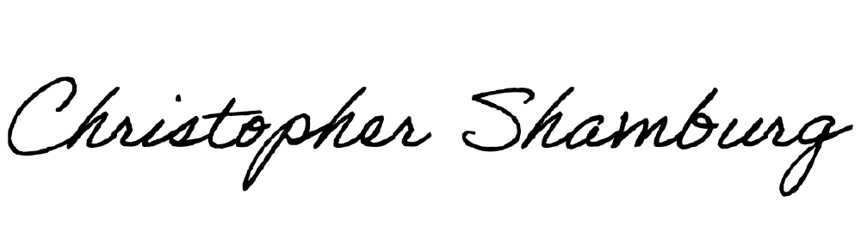 X

Principal Investigator

# X

Co-Principal Investigator

# X

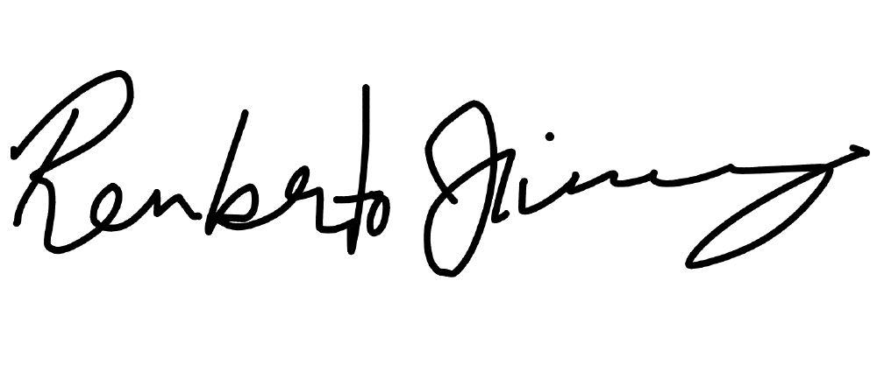Co-Principal Investigator

# X

Co-Principal Investigator

# X

Co-Principal Investigator

\***Instructions for signatures**: First, save your application file and then open it.

Sign the document by right clicking on the signature line and selecting “Sign.” **DO NOT SAVE** the file, **simply CLOSE IT**. The signature will be automatically saved. If applicable, send the file as an email attachment to the next signatory. Every subsequent signatory must also follow these instructions.

Please submit the completed application, checklist, and accompanying documents as one word document to [kresch@njcu.edu.](mailto:kresch@njcu.edu)

**All applications must be submitted by the NJCU faculty or staff member serving as the Principal Investigator. Neither students nor external researchers may submit an application.**

##### APPENDIX A. Protocol Summary*; Surveys, including recruitment materials as applicable; and consent forms.

Please note: The protocol summary (5-page maximum) should only include the central elements of the project such as the rationale, objectives, methods, populations, and period.

This research will identify and interview people who listen to podcasts outside of formal education to “learn new things” as a primary reason. This is underexplored territory on a nuanced topic--how people learn with a new technology, and the analysis of open-ended interview questions is a good fit for rich, complex, and unexpected data. The participants will be recruited in three ways: social media, the researchers’ personal networks, and snowball sampling. There will be a conscious effort to recruit a group of diverse participants in age, gender, and ethnicity. This will be a goal in the initial phase of recruiting from our personal and professional networks, and we will adjust our recruitment for diversity as we proceed. Participants will be offered a $20 Amazon Gift Card for their participation.

The home of the social media campaign will be a page on the NJCU Educational Technology Department’s Web site explaining the project with a link to the permission form. This is the text that will appear on the Web site:

Podcast Listeners and Informal Learning

This is the page for the research project Podcast Listeners and Informal Learning. The purpose of this research is to explore the role that podcasting has in the out-of-school learning of adults. Podcasting has experienced surprising growth in the last 15 years, and the main reason people give for listening to podcasts is “to learn new things.” The main research questions are how and what do adults learn from their recreational use of podcasts and how does this learning affect their lives?

We are currently looking for volunteers to be interviewed. The interview will take approximately 60 minutes and can be done via Zoom or in person. If you are a podcast listener and believe that you ‘learn new things’ when you listen, please consider

participating. For participation you will receive a $20 Amazon Gift Card. Please **click and read the permission form (URL / Appendix A)** if you would like to participate.

### This page will be promoted and shared on the LinkedIn and Facebook pages of the NJCU Educational Technology Department. I will ask permission of the administrators of podcast-related Facebook groups if I can share the link in their groups. I will also increase the reach of the post by boosting it as a paid post. I estimate this will not exceed $300 and target an audience using “podcasting” and “podcasts” as keywords in the audience demographics. The post on social media will read as follows:

“Do you listen to podcasts and learn new things when you do? Participate in the research “Podcast Listeners and Informal Education”. You will receive a $20 Amazon Gift Card for your time. Please check here for

more information (URL)”

Aside from social media, researchers will ask people in their personal and professional networks to participate. The researchers will approach potential participants with this query: “I’m doing research on podcasting and learning. I’d like to email you a description and permission form. If it seems like something you’d like to do, could you let me know?” If the potential participant is agreeable, an email with the consent letter will be sent (Appendix A). One a participant signs the online consent letter and includes their email address, we will contact them to set up an interview.

All interviews will be conducted either on Zoom or in person following a script of 14 questions (Appendix B) by one of the researchers. Participants who are recruited through a personal or professional network of a researcher will be interviewed by that researcher. Participants who are recruited by social media or snowball sampling will be assigned to a researcher by me, Christopher Shamburg, the Principal Investigator (PI). Interviews will be conducted either in person or via Zoom, and they will be recorded with a smartphone or the Zoom recording feature. The interviews will be transcribed using Otter.ai software, so no person other than the researchers will be listening to the recordings. After an initial transcription, the interviewer will revise the transcript making appropriate corrections.

Along with social media and the researchers’ networks, we will recruit using snowball sampling. At the end of an interview, participants would be asked if they knew anyone who likes listening to podcasts and if they would mind forwarding the link of our Web page to that person.

All interviews will be coded based on the broad research questions of what and how the participants learn and then how this learning affects their lives. The codes will be refined to themes in an iterative process. The main researcher will conduct the coding and meet regularly to share questions, results, analysis, and coding patterns with the co-investigators for their analysis and feedback. The transcripts will be analyzed in Atlas.ti as they are recorded and transcribed. The coding will be done in three rounds—1) line-by-line open coding 2) focused coding 3) axial coding as we move to more specific themes (Alexander, 2020; Saldaña, 2016). As soon as the first interview is transcribed and coded by me, Christopher Shamburg, the PI. I will hold weekly meetings with the team to review the codes and the process, solicit feedback, and revise the coding.

After the transcriptions by the co-investigators are sent to the PI, the recording files and transcripts will be sent to the PI and removed from the co-investigators’ hard drives and smartphone. The Principal Investigator will keep all the material in a password protected folder on his hard drive and a password protected cloud backup. This information will then be deleted three years from the publication of the research.

**APPENDIX A: Permission Form TEXT**

Dear Potential Participant,

We are writing to ask you to volunteer in our study *Podcast Listeners and Informal Learning*. The purpose of this research is to explore the role that podcasting has in the out-of-school learning of adults. How people learn from podcasts is an important and under-explored area in educational research. This study can shed light on how people learn today outside of schools with newer technologies. If you listen to podcasts and learn new things when you do, we would value your insights.

Your participation would involve an interview of approximately 60 minutes. One of the researchers would ask you questions about your podcast listening and learning habits. He or she will record and transcribe the interviews— removing your name and any other identifying information to maintain your privacy. You can participate in person or by Zoom, and we will arrange the interview at a time that is convenient for you. We will use software to transcribe the interview from audio to print so we can better analyze it. We are then going to analyze and compare your answers to other data. Our work will be published in an academic journal and presented at conferences. You will be given a $20 Amazon Gift Card for your participation. If you agree to participate, you can withdraw at any time.

If you have any questions before or during the process, please contact the Principal Investigator, Dr. Christopher Shamburg [cshamburg@njcu.edu](mailto:cshamburg@njcu.edu) 201-200-3078 or Dr. Merriem Bendaoud, the Chair of NJCU’s Institutional Review Board (IRB) at [mbendaoud@njcu.edu](mailto:mbendaoud@njcu.edu) 201-200-3461.

Podcasting is a unique and powerful medium. Sharing your experiences and insights can help us understand its role in lifelong learning and development. Please research out if you have any questions.

Thank you,

Dr. Christopher Shamburg, Principal Investigator

I agree to participate in the study Yes No

Full Name (typed if online / signed if in print) Email Address

**Appendix B: Script and Questions for Interview**

### Thank you for participating. We are conducting this research to explore how people learn outside of schools with podcasts. We are looking at people who listen to podcasts and learn new things—this can be fitness, spirituality, food, travel, motivation, politics, culture, entertainment news, entrepreneurship—mainly topics where the learning can affect how you think and act outside of podcasting.

1. What are some of your favorite podcasts that seem to fit this description? Feel free to scroll through your phone to think of a few.
2. how and when do you usually listen to podcasts?

(Instructions to Interviewer (ItI): Listen carefully, you are going to follow up on podcasts that seem to have learning component, “learning podcasts,”—put broadly: news, how-to, health and fitness, travel, food spirituality, motivation, entrepreneurship…even niche topics like witchcraft or doomsday prepping…almost anything except narratives like sci-fi, horror, true crime or stand up comedy (unless in law enforcement or a stand-up comic). Depending on their responses, you may want to discuss one or podcast at a time and the repeat the questions.)

1. Do you remember how you found out about this podcast? Can you describe that.
2. What is it about *the podcast* that keeps you listening? (ItI: you may have to repeat this question for

each “podcast”. Don’t rush. Note the learning podcasts and come back to them one at a time)

1. How did you get interested in this topic?
2. Have you learned new things from listening to this podcast? (ItI: gently probe for specifics...let them talk. Follow up with prompts for them to keep talking.)
3. Do you think you have done anything new or different because of listening to this podcast—(ItI: follow up with suggestions specific for the podcast--for example if it’s a health podcast, ask about changing diet, nutrition or exercise; if it’s a career podcast, ask about doing things differently on the job…other follow up direction—buy a book, tried a new recipe, planned a trip).
4. Are there any ideas that you’ve gotten from listening to a podcast that stay with you—that you continue to think about after listening?
5. What do you like about podcasts in general?
6. Do you talk to others about podcasts you listen to? (ItI: if this is “no” or “not really” ask why not.)
7. (ItI:If “yes” ask) Is this for all podcasts about the same? Are their times that you don’t like to talk to people about podcasts? ( ItI: if yes, ask “why ?” Your follow up questions should probe when and why they do or do not talk to others about it?
8. (ItI: Possible follow up --) Do you ever listen to material that you would not feel comfortable discussing

with others? (ItI if yes, ask “can you give some examples?”)

1. Do you follow or participate in any online activities related to those shows? For example, do you follow a Facebook group, Reddit page, or subscribe to an email newsletter? (ItI: if yes, ask “How much are you a reader and how much are you a poster or commenter?”)
2. Thank you, again, your personal information will be kept confidential. Could you tell me your age, occupation, and your highest educational degree completed, and what that was in? What do you do for a living?

