Spearman Correlation Coefficient
Juan Rodriguez
New Jersey City University
EDTC 813
7/21/2021

Introduction
The Spearman Correlation Coefficient is the strength of the dependency relation between two variables and the nonparametric ratio of the process. These variables are estimated somewhere on an ordered scale. It is represented by the symbol rs (rho). This test is used for sequential variables with important hypotheses to guide the second relevance of the Pearson project (Kumar and Abirami, 2018). For example, you can use Spearman's correlation to understand the relationship between the type of school and learning opportunities and professional development; or "The administration successfully supports students, teachers, and parents during the shutdown: Or "learning opportunities and professional development in educational technology independent of my school district." It could also be between school type and "I consider myself a tech-savvy educator"; or "My students had the technological resources at home to be successful before the shutdown."
This correlation exercise required two variables: ratio, ordinal, or interval. Although you generally want to use the quadratic correlation of the Pearson term on the ratio or interval data, you can use the Spearman correlation when the hypothesis is uniquely ignored. Nonetheless, the Spearman correlation determines the strength and direction of the monotonic correlation between the two variables, rather than the direct correlation between the two elements, which is determined by the Pearson relationship (Kumar and Abirami, 2018). A monotonic relationship performs one of the following actions: (1) When the value of one variable increases, the value of another variable also increases; or (2) When the value of one variable increases, the value of another variable decreases.
Assumptions
When you decide to use Spearman correlation to break down the data, part of the loop includes checks to ensure that the data you need to dissect can be verified using Spearman correlations. You need to do this because if the data "exceeds" the assumptions required for a Spearman correlation, it may be appropriate to take advantage of Spearman's correlation to provide you with substantial results (Kumar and Abirami, 2018). Gradually, checking these three hypotheses adds more opportunities to the exam. I hope you click on more options in SPSS Statistics and consider the data when doing the survey. However, this is by no means a tedious task.
The two variables solve the paired observations. For example, suppose you are passionate about the correlation between school type and another variable. The individual aggregate perceptions reflect the scores of individual participants for each variable (for example, the type of school of "Participant 1" and the teacher experiences of "Participant 1"). Ninety-nine participants take the survey, which means there will be 99-paired observations.
There is a monotonic correlation between these two variables. When the values ​​of the variables increase together or when the value of one variable increases while the value of another variable decreases, there is a monotonic relationship. Although there are several ways to check if there is a monotonic relationship between the two variables, we recommend that you use SPSS Statistics to create a point cloud. You can plot one variable against another and then check the scatter plot outward to check for monotony.
Using rank correlation to test for association
Likewise, as with some other theoretical tests, for the Spearman test, you calculate the test metric from the sample and compare it to a critical value suitable for the sample size and level of significance. The test is 1 or 2 tails. As long as there is no relationship between the variables, invalid assumptions must be written. This reflects the motivation of the test: to study the potential connections of the entire population. It may be tempting to write the theory of invalidation as "there is no positional correlation between the variables," but this is wrong and can be confusing. This example may have some degree of hierarchical relationship. However, the motivation behind the test is to attract the public. It can be compared to 0 ρ = in the pmcc test (Kumar and Abirami, 2018). The term affiliation covers the broad correlation between these two variables, so it is not shocking that there is no discernible document on the proportion of affiliation that is not linked.
There are two things you need to remember. They can make you less stressed that strategies can produce a variety of results. First, the invalid assumptions tried are unique. In the Pearson case, the invalid theory is serious and has nothing to do with the whole binary population. Interestingly, Spearman's test takes into account a wider range of invalid unaffiliated assumptions. In addition, there is the topic of the sensitivity of tests and their reliance on substantive assumptions. If the suspicion of bivariate normality is correct, Pearson's test can be further refined (implying being more impressive in the further development of measurable work). In any case, the Spearman test offers more protection in case this assumption is incorrect.
Support from administration during shutdown
The current pandemic has forced most educational systems to adopt alternatives in education and learning. Many training school executives upload the activities to the Internet to continue teaching when schools are shut down. Given the possibility of not providing tutoring, online schooling has become an important tool to improve the school's capacity during the shutdown period. There is still concern that Internet learning is an instructive alternative, especially since there is no universal access to infrastructure (software and hardware) and teachers and students are not well prepared for it—the new order of education and learning on the web.
Developing a strong vision for learning can help students overcome potential technology-related difficulties caused by learning on the Internet, for example, staying focused or keeping enough inspiration in online courses. They are also essential in helping students successfully use data and exchange technologies (ICT) and benefit as much as possible from new advances in learning (Su and Li, 2021). Promote learning perspectives, self-direction, and inner inspiration to discover how to play an important role in the further development of school exposure. Still, this can be particularly important if learning on the Internet continues.
The help they receive from the administration and the good role models they see will influence the mentality and attitude of the students. All kinds of government support, including enthusiastic support from parents and enthusiasm from teachers, are important in improving the learning attitude and ensuring that students have an attitude and dispositions that can improve their ability to use networking learning opportunities. However, some authorities may try to provide such assistance due to lack of time, insufficient computer capacity, or program rules, especially during the COVID-19 emergency.
Learning opportunities and professional development
The other variable under focus is “Before the shutdown, I sought learning opportunities and professional development in educational technology independent of my school district.” When people understand the mastery of technology education as a potentially revolutionary learning opportunity, the outcome can be redefined. Perhaps focusing on technical skills, integrating group discussions, community working groups, and advancing educational programs can help employees begin to test their tips and learning ideas as they go. 'They learn pedagogical techniques. Advancing Skills can connect with teachers, reflect on their work, and place in our global and local areas. Skilled designers can help develop smart practices and stimulate the advancement of learning networks, which can facilitate training networks (Sert and Boynuegri, 2017). The call to integrate technology into teaching can be the first step in the professional development of teachers. This exam views teacher planning and expert promotion as professional preparation and links improved writing and teaching technicians' practices to the pioneering learning hypothesis of adult education. We can see that Spearman's correlation coefficient, r_{s}, is 0.037 and that this is statistically significant (p = .724), as shown in Table 1 below. The relationship is positive.
Table 1: Spearman’s rho for the school type and learning opportunities and professional development
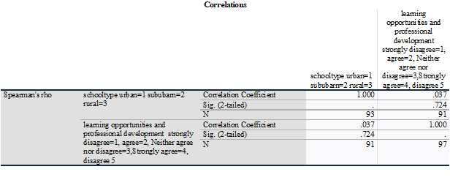
As teachers build their dreams as facilitators rather than distributors of classroom data and connections in the global environment, they may encounter new perspectives in their personal and expert local work. Find new examples, which mean more training and learning opportunities through learning teaching techniques. The competent improvement plan becomes the freedom to grow gradually and efficiently. The experience of placing themselves in the current environment of innovation and change can also enable teachers to understand how to adapt to new data and changes - this is a demand for long-term learning.
Teacher's Use of technology
Personal attributes, such as educational level, age, gender, teaching experience, knowledge of computers for teaching purposes, and attitudes towards computers will all affect the student's performance—acceptance of technology. Teachers are required to accept and use ICT—teaching and learning activities. However, the readiness of teachers to integrate ICT into teaching determines the feasibility of the technology, not its presence in the classroom. Teachers' perception of technology greatly affects their perception of computing. As pointed out, tension, lack of certainty and ability, and fear often indicate that ICT places ordinary learning components in the back sitting position. In turn, this affects teacher acceptance and understanding of teachers (Sert and Boynuegri, 2017). The personal qualities of mixed ICT education are important. We found that Spearman's correlation coefficient, r_{s}, is -0.131 and that this is statistically significant (p = .402), as shown in table 2. The relationship is negatively weak.
Table 2: Spearman's rho for the school type, and I consider myself a tech-savvy educator.
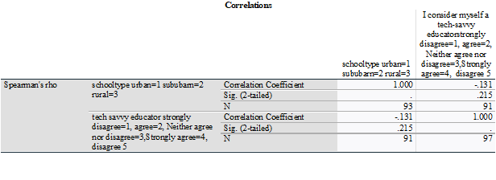
Some studies have detailed that teachers' participation in teaching does not affect their use of computer technology in teaching. Most reviews show that demonstrating experience affects the effective Use of ICT in the study room. Gorder (2008) reveals that the teacher's experience essentially corresponds to the actual Use of technology. Its inspection revealed that the successful Use of the PC was determined as an innovative comfort level and freedom to guide teachers, taking into account the needs of the students. Likewise, successful teachers are not sufficiently prepared to coordinate ICT in their education.
Table 3: Spearman’s rho for the school type and Years of experience
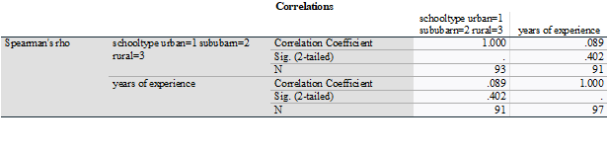
We can see that Spearman's correlation coefficient, r_{s}, is 0.089 and that this is statistically significant (p = .402). The relationship is positive but weak. Personal attributes, such as teaching experience, knowledge of computers for teaching purposes, and attitudes towards computers will all affect the performance. However, the readiness of teachers to integrate ICT into teaching determines the feasibility of the technology, not its presence in the classroom. Teachers' perception of technology greatly affects their perception of computing. As pointed out, tension, lack of certainty and ability, and fear often indicate that ICT places ordinary learning components in the back sitting position. In turn, this affects teacher acceptance and understanding of teachers. The personal qualities of blended ICT education are important.
Conclusion
The Spearman Order Relation Coefficient is the strength of the dependency relation between two variables and the nonparametric ratio of the process. We have used Spearman's correlation to understand the relationship between the type of school and learning opportunities and professional development; or "The administration successfully supports students, teachers, and parents during the shutdown: Or "learning opportunities and professional development in educational technology independent of my school district." The relationship is positive but weak on Spearman's rho for the school type, learning opportunities, and professional development. The Spearman's rho for the school type and I consider myself a tech-savvy educator relationship is weak.

References
Kumar, A., & Abirami, S. (2018). Aspect-based opinion ranking framework for product reviews using a Spearman's rank correlation coefficient method. Information Sciences, 460, 23-41.
Sert, N., & Boynuegri, E. (2017). Digital Technology Use by the Students and English Teachers and Self-Directed Language Learning. World Journal on Educational Technology: Current Issues, 9(1), 24-34.
Su, L., & Li, H. (2021). Project Procurement Method Decision-Making With Spearman Rank Correlation Coefficient Under Uncertainty Circumstances. International Journal of Decision Support System Technology (IJDSST), 13(2), 16-44.

